**LAPORAN**

**PRAKTIK DESAIN DAN PEMROGRAMAN WEB**

“HTML Dasar”



**Oleh :**

**Novia Nur Hamidah**

**NPM. 203307071**

**JURUSAN TEKNIK**

**PROGRAM STUDI TEKNOLOGI INFORMASI**

**POLITEKNIK NEGERI MADIUN**

**2021**

1. **Tujuan Praktikum**

Diisi secara ringkas sesuai dengan indikator di modul praktikum.

1. **Dasar Teori**

………………………………………………………………………………………………………………………………………………………………………………………………………………………………………………………

1. **Hasil Praktikum**
2. Percobaan 1
3. Kode Program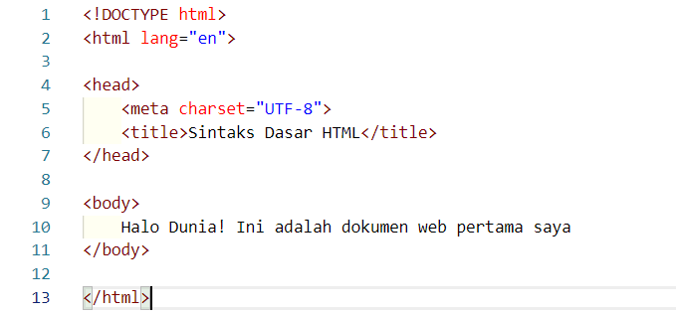
4. Hasil Program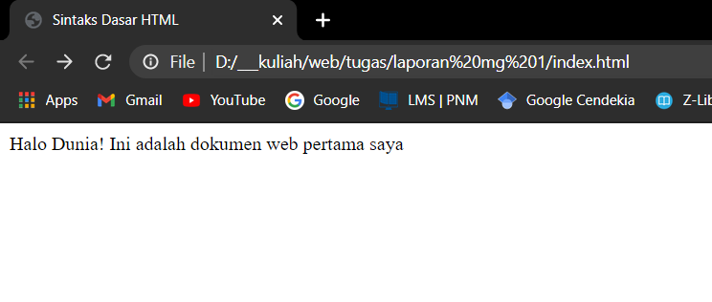
5. Analisa

….………………………………………………………………………….

1. Percobaan 2
2. Kode Program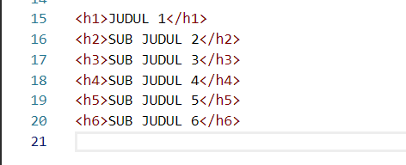
3. 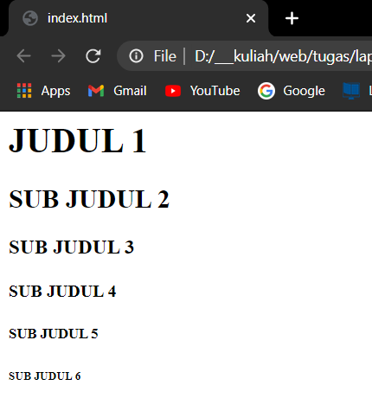Hasil Program
4. Analisa

….………………………………………………………………………….

1. Percobaan 3
2. Kode Program

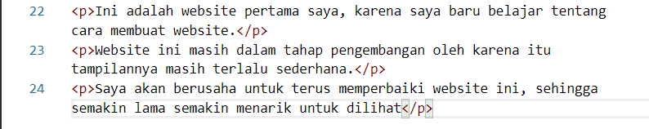

1. Hasil Program

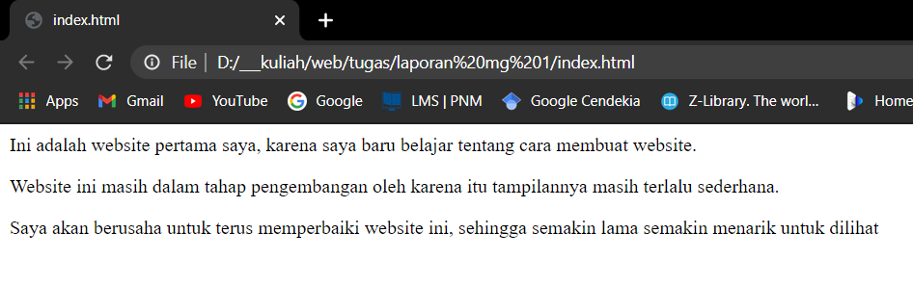

1. Analisa

….………………………………………………………………………….

1. Percobaan 4
2. Kode Program

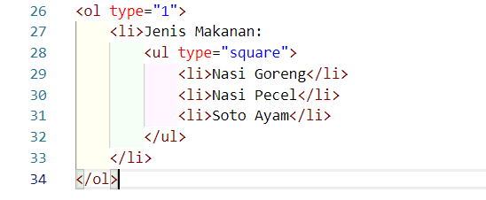

1. Hasil Program

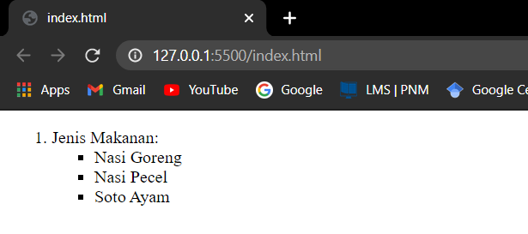

1. Analisa

….………………………………………………………………………….

1. Percobaan 5
2. Kode Program



1. Hasil Program

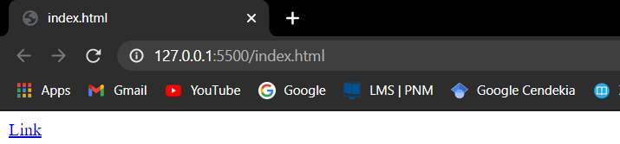

1. Analisa

….………………………………………………………………………….

1. Percobaan 6
2. Kode Program



1. Hasil Program

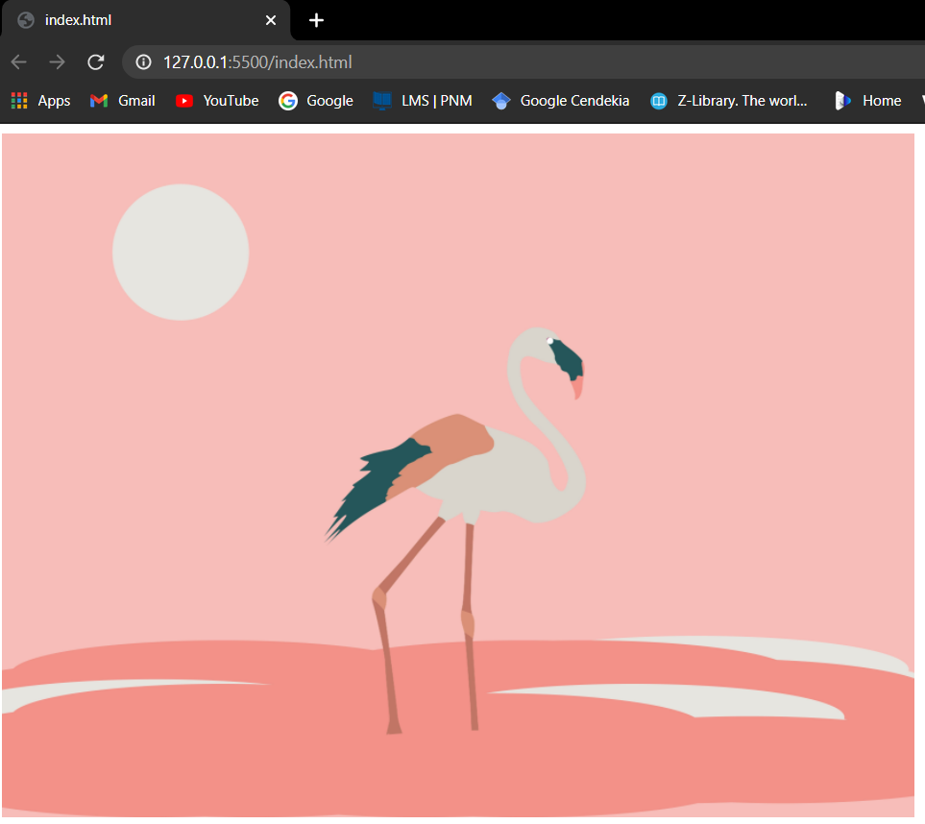

1. Analisa

….………………………………………………………………………….

1. Percobaan 7
2. Kode Program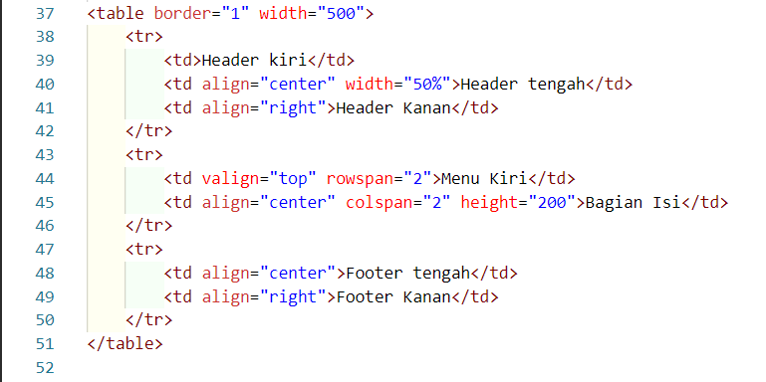
3. Hasil Program

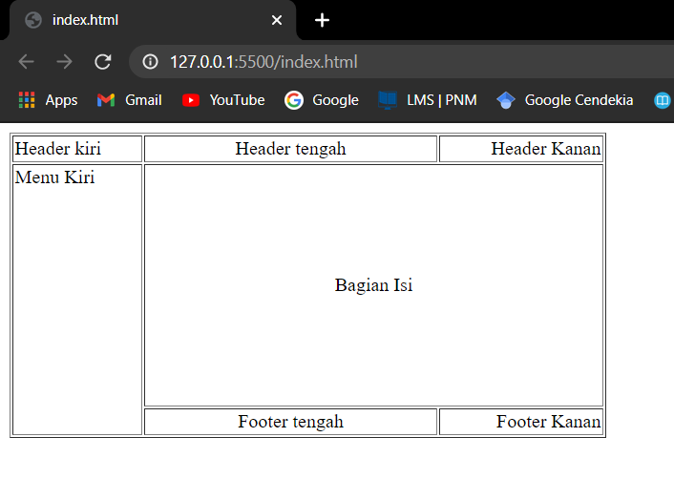

1. Analisa

….………………………………………………………………………….

1. Percobaan 8
2. Kode Program

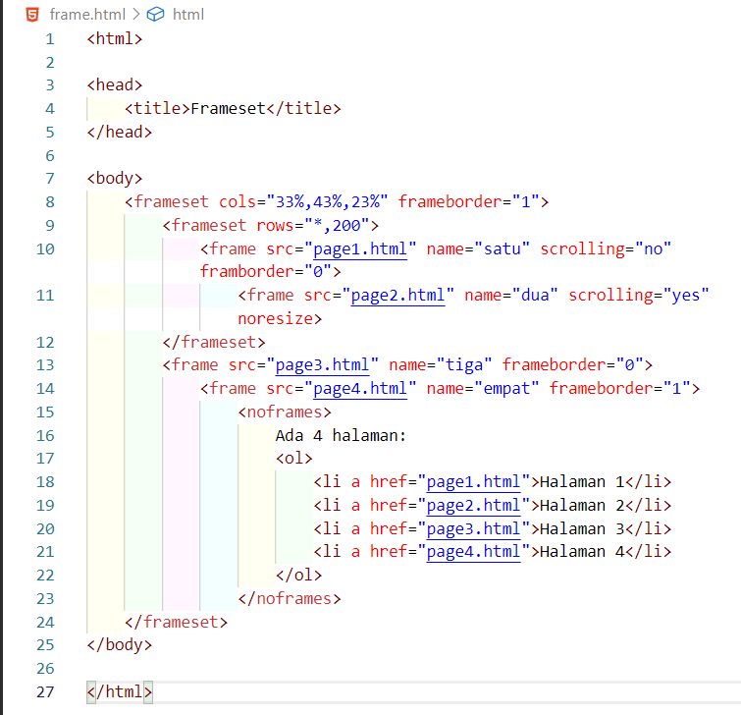

1. Hasil Program

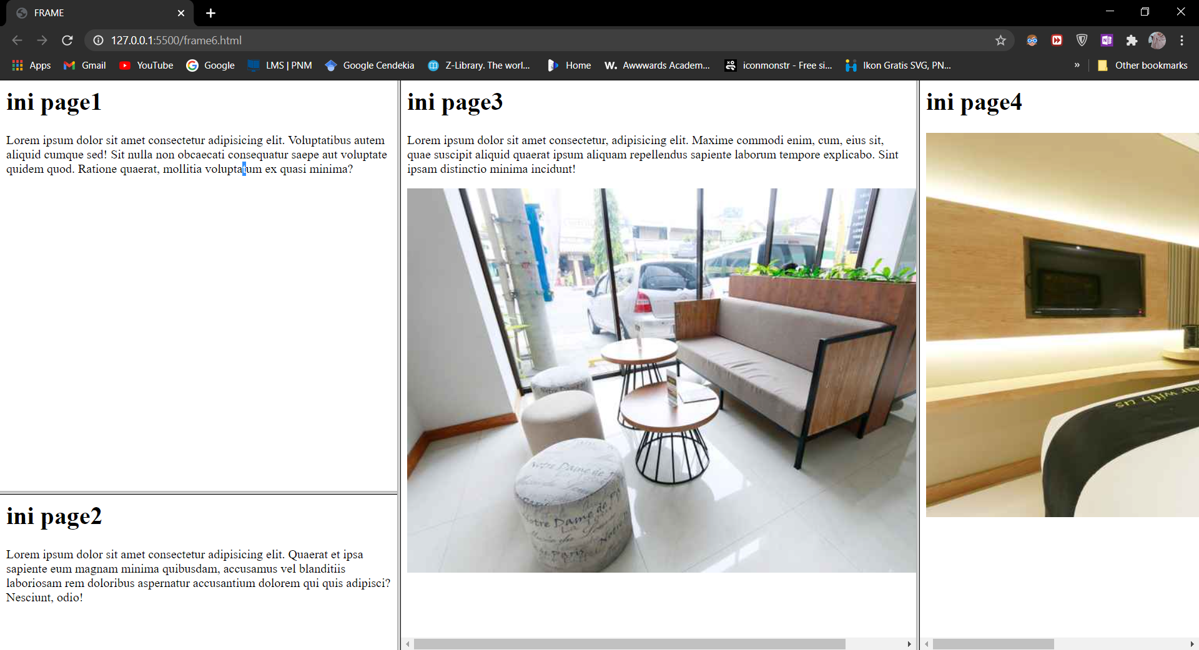

1. Analisa

….………………………………………………………………………….

1. Percobaan 9
2. Kode Program

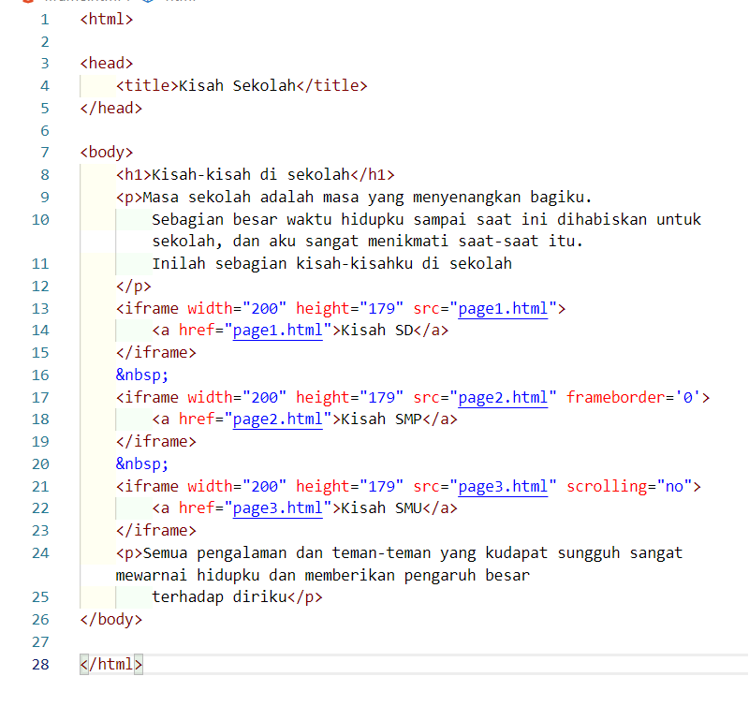

1. Hasil Program

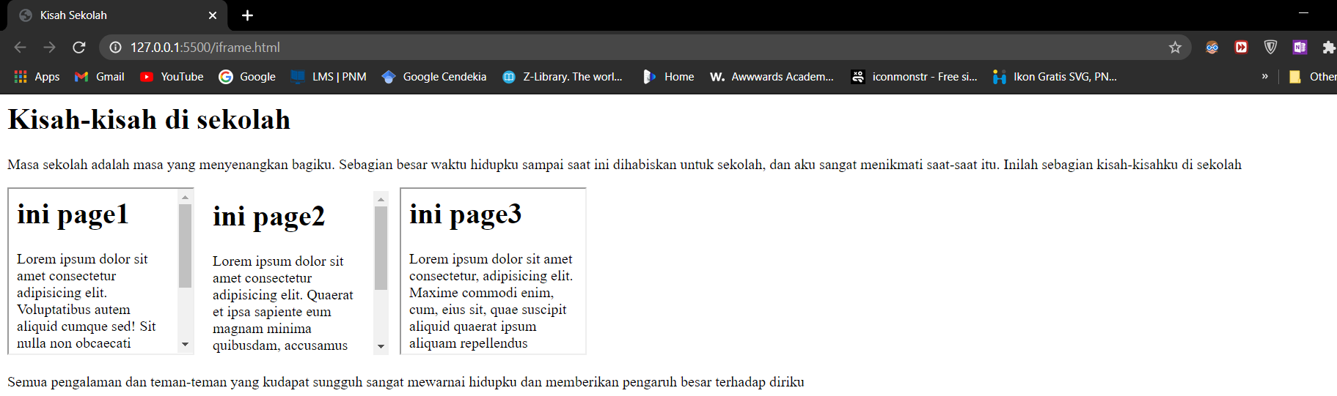

1. Analisa

….………………………………………………………………………….

1. Percobaan 10
2. Kode Program

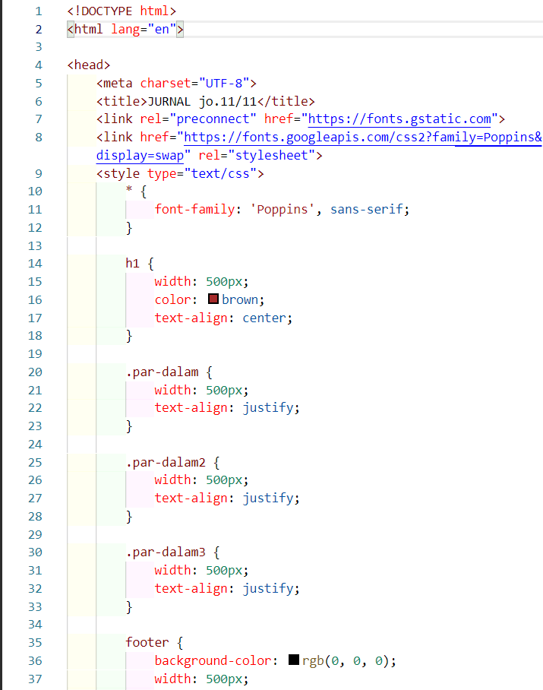 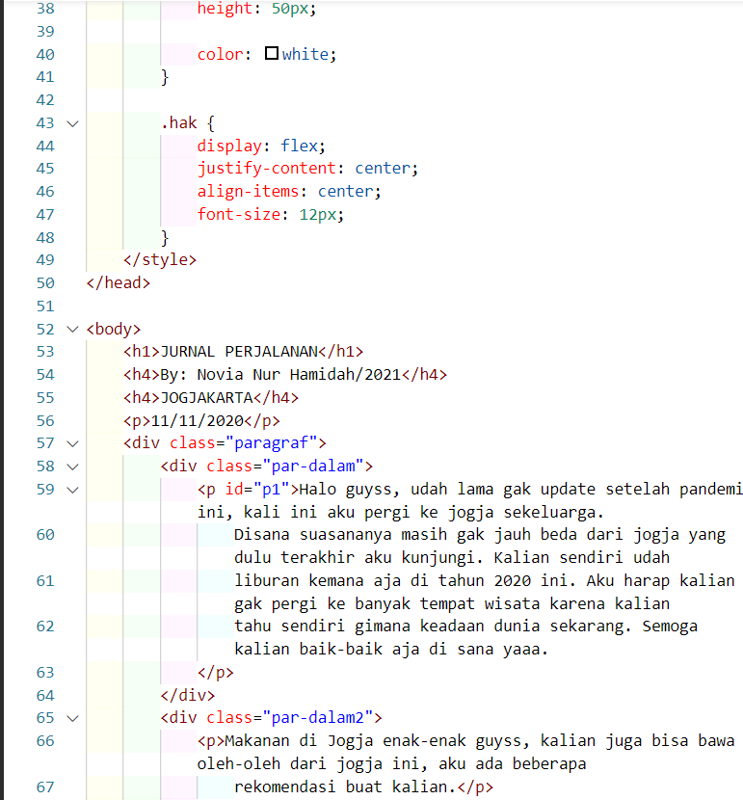 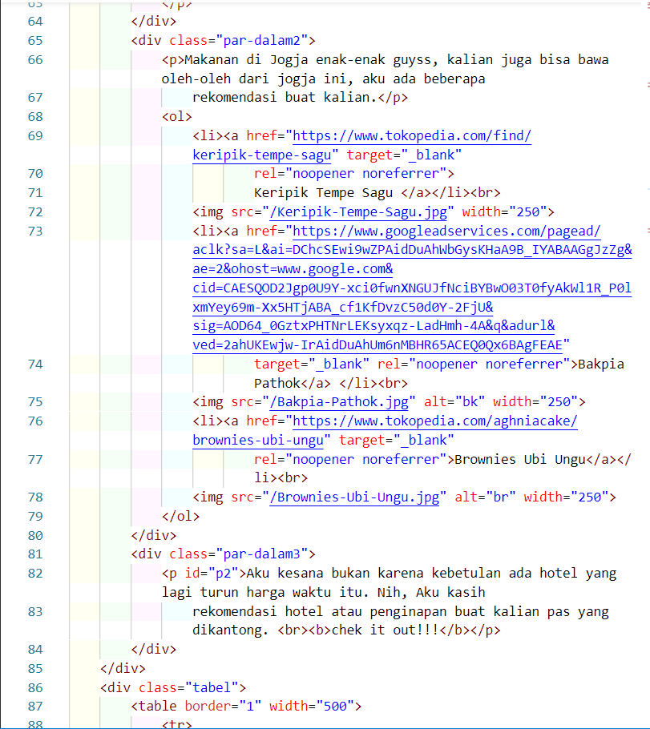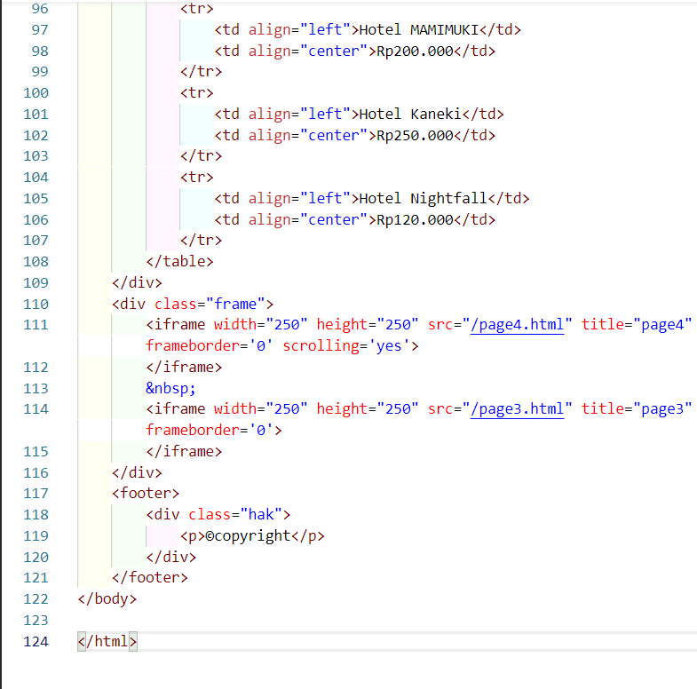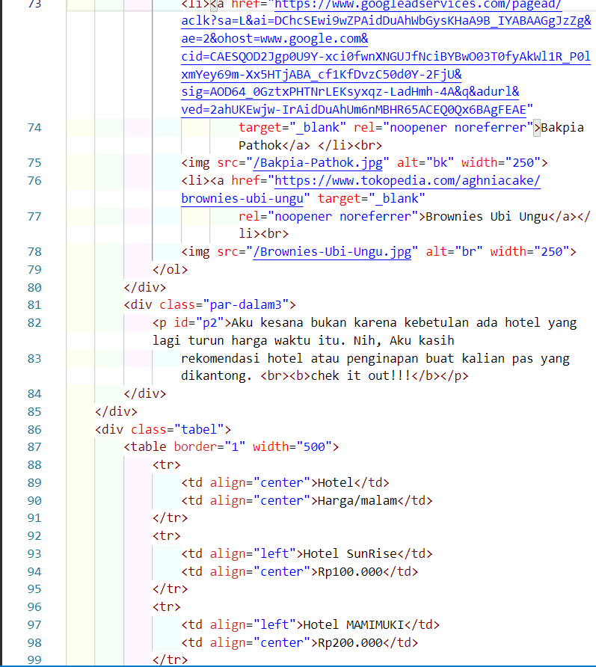

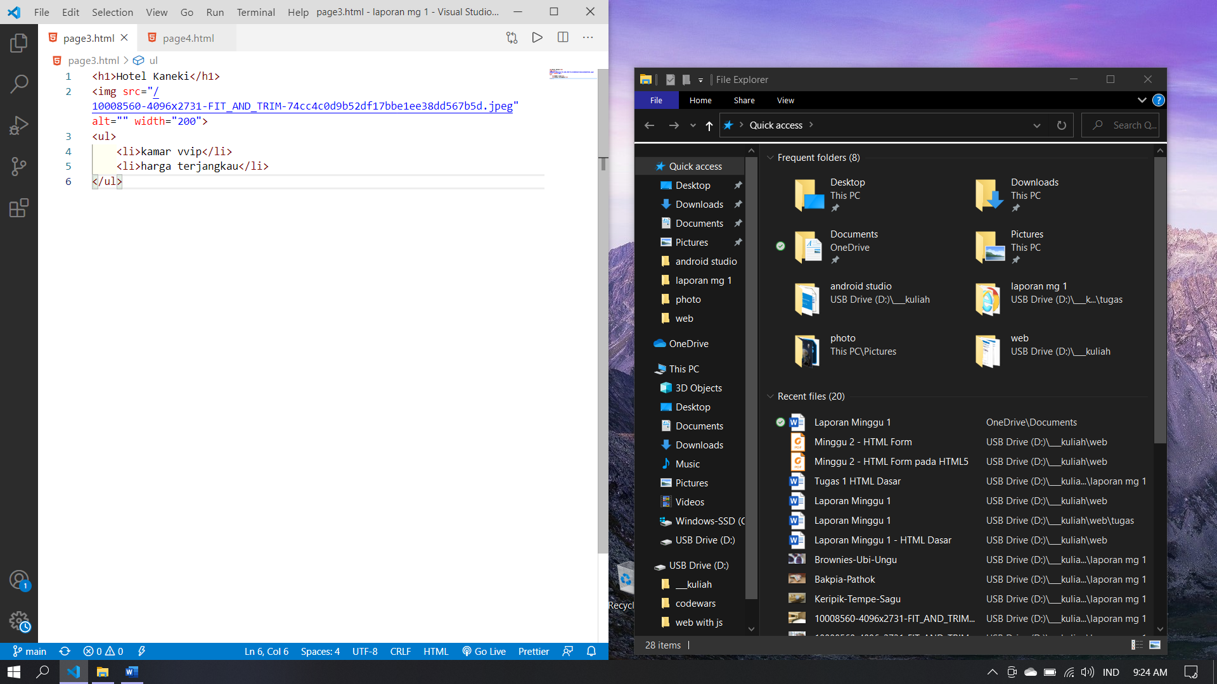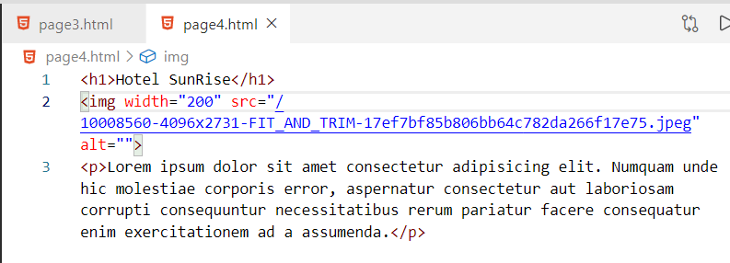

1. Hasil Program

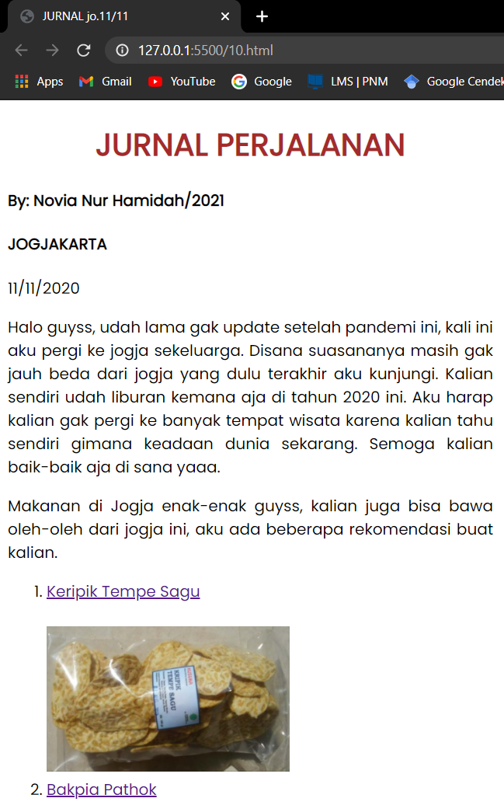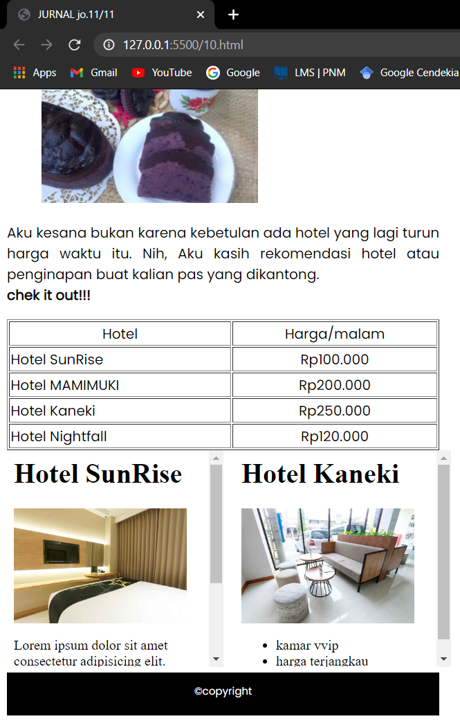

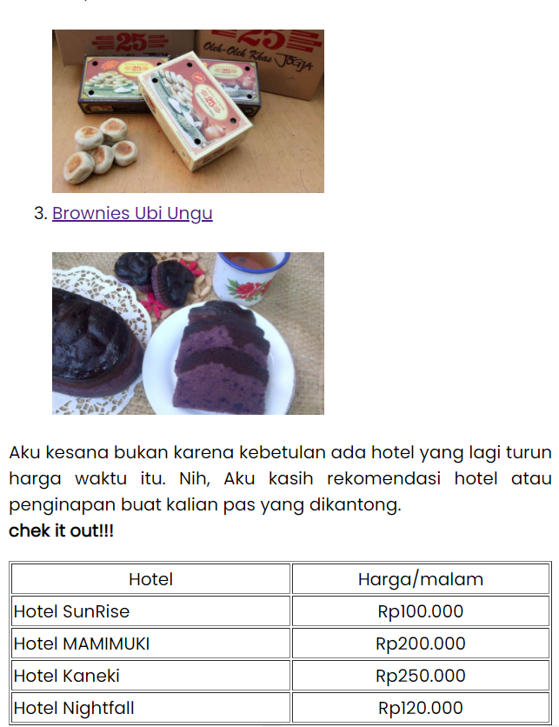

1. Analisa

….………………………………………………………………………….

1. **Kesimpulan**

………………………………………………………………………………………………………………………………………………………………………………………………………………………………………………………

|  |  |
| --- | --- |
| Pengesahan Laporan Sementara | |
| Tanggal | Acc |
|  |  |